Application Specification

Unique ELD Username to each user account
- Create Account using: Driver’s first, last name, Driver’s License (DL), DL issue state, Account Type (ELD User, Support Personal) Password. Note: DL cannot be part of Username
- Provide carrier to sync the login credential with support system.
Duty of ELD
- Off duty, or OFF or 1
- Sleeper berth, or SB, or 2
- Driving, or D or 3
- On-duty not driving, ON, or 4
Manual Entry
- Annotation
- Driver’s location description
- Output file comment when directed by an authorized safety officer
Manual Entry and Verification (Note: if automatically populated then driver must be able to change)
- Unit Number of Vehicle
- Trailer Number if applicable
- Shipping document if applicable
ELD data automatically recorded.
- Date
- Time
- CMV geographic location information
- Engine hours
- Vehicle miles
- Driver or authenticated user identification data
- Vehicle Identification data (VIN)
- Motor carrier identification
- Change of duty status device must record (Date, Time, CMV geographic location, Engine hours, Vehicle miles, Driver or authenticated user identification, VIN, Motor Carrier identification.
- When vehicle in motion, if no duty status was changed in previous 1 hour, then record a duty status at every 1 hour interval by including record (Date, Time, CMV geographic location, Engine hours, Vehicle miles, Driver or authenticated user identification, VIN, Motor Carrier identification.
- If recording duty status when in authorized personal use, then Engine hours, and Vehicle must not be record, all other data items will be record with CMV geographic location recorded to single decimal point. (Eg. 49.5, -122.2)
- Change in special driving category, ELD must record of duty with (Date, Time, CMV geographic location, Engine hours, Vehicle miles, Driver or authenticated user identification, VIN, Motor Carrier identification). Special driving includes, authorized personal use, Yard Moves etc. These categories are defined by Motor Carrier.
Certification of Driver’s Daily Record (Log)
- ELD must provide the driver an option to certify driver’s record for every 24-hour period.
- ELD must provide the driver an option to recertify driver’s record for every 24-hour period.
- When driver certify or recertify, ELD must record, date, time, driver identification.
- Driver must certify driver’s record by affirmatively selecting “Agree” immediately following a statement that must read, ‘‘I hereby certify that my data entries and my record of duty status for this 24-hour period are true and correct.’’

Log in / Log out
- When authorized user logs into or out an ELD, ELD must record date, time, engine hours, vehicle miles, driver or authenticated user identification date, VIN, Motor Carrier identification).
Malfunction and data diagnostic
- When ELD detects or clears a malfunction or data diagnostic event, ELD must record date, time, engine hours, vehicle miles, driver or authenticated user identification date, VIN, Motor Carrier identification).

Special driving categories; other driving status
- Authorized personal use
- Yard moves
- Driver exempt from use of ELD
Guide for special driving categories
- Driver must select special driving category when he/she start and must deselect when the status ends.
- Driver must enter an annotation when prompted by ELD.
- Carrier may configure an ELD to designate a driver as except from ELD use.
- ELD must prompt driver when he/she is using the vehicle under special category and under 390.3(f) (such as earth quick relief.
Driver submitted records to employer
- Driver must submit records to motor carrier in accordance with § 395.8(a)(2)
- If any edits are made, driver must recertify the records and submit to motor carrier
Editing of record
- Each change must be annotated either done by driver or support personal.
- In team drivers, if wrong driver was assigned driving-times hours by ELD and if both of drivers were both indicated in each other’s records for that period as co-drivers, driving time may be edited and reassigned between the team drivers following the procedure supported by ELD.
- Carrier may propose edits, driver must review and certify the edits and resubmit the records to carrier.
- Edits requested by any system or by any person other than the driver must require the driver’s electronic confirmation or rejection.
Non-Authenticated driver logs
- ELD must associate the non-authenticated operation of CMV with a single account labeled “Unidentified Driver’’ as soon as vehicle is in motion
- ELD must prompt the user to review any unassigned driving time driver must:
- Assume any records that belong to the driver under driver account or marks as record not belong to driver
- Motor carrier must review unidentified driver records and assign appropriate driver or explain why the time is unassigned.

EDL DESGIN INFORMATION
ELD Users
- CMV Drivers employed by a motor carrier
- Support personal who have been authorized by motor carrier to:
Create, remove, and manage user accounts
Configure allowed ELD parameters
Access, review, and manage drivers’ ELD records on behalf of the motor carrier
- ELD must separate drivers and motor carrier support personal accounts (non-drivers)
- Driver account must not have administrative rights to create new accounts on ELD
- Support personal account must not allow recording of ELD data for its account
- ELD must have unique driver account named: Unidentified Driver Account”
- Login credential must strong (Username and Password)
- Driver must be only allowed to view his own records only
- ELD must allow concurrent authentication for team drivers.
More than 1 ELD used by driver
- If driver uses more than 1 ELD during motor carriers operation. Driver must be able to produce current 24 hr duty status and previous 7 consecutive days.
Non-Authenticated operation
- If driver does not login to the system, ELD must provide visual or visual and audible warning reminding the driver to stop and login to the ELD as soon as the vehicle is in motion.
- Record accumulated driving and on-duty not drive time with ELD defaults
- Not allow entry of any information into the ELD other than a response to login prompt
Engine Power Status
- ELD must be powered and become fully functional within 1 minute of vehicle’s engine receiving power and must remain powered for as long as the vehicle’s engine stays powered.
Vehicle Motion Status
- Vehicle must be considered in motion when exceeds the set threshold
- Vehicle must be considered in motion until its speed falls to 0 miles per hour and stays at 0 miles per hour for 3 consecutive seconds then the vehicle will be considered stopped.
- Threshold value to determine in-motion state cannot be configured greater than 5 miles.
- Speed must be acquired from ECM if ELD is required to have link with data bus.
Vehicle miles
- ELD must monitor vehicle miles as accumulated by a CMV over the course of an ignition power on cycle and over the course of CMV’s operation
- Miles must be converted to units of whole miles.
- ELD must use the odometer message to determine accumulated vehicle miles since engine’s last power on instance
Engine hours
- ELD must monitor engine hours as accumulated by a CMV over the course of an ignition power on cycle and over the course of CMV’s operation
- Engines hours must be converted to tenth of an hour.
Date and Time
- ELD must obtain and record the date and time information automatically without allowing any external input or interference from motor carrier, driver, or any other person.
- ELD must be synchronized to UTC and absolute deviation from UCT must not exceed 10 minutes at any point of time.
CMV Position
- CMV must automatically determine the position in standard latitude/longitude coordinates with accuracy of -/+ .5 Mile
- CMV position must be expressed in decimal degrees to hundreds of a degree precision.
- ELD must be able to acquire a valid position measurement at least once every 5 miles of driving
CMV VIN
- VIN must be automatically obtained from ECM if available on vehicle data bus.
Driver’s Manual Entries
- ELD must only prompt the driver to input information when CMV is stationary and drivers duty status is not on-duty driving except for condition when the ELD changes to duty status of on-duty after 5 minutes of stationary status then ELD must prompt the driver to confirm driving.
- If the driver duty status is driving, ELD must allow the driver to who is driving to change the duty status to another status.
- ELD must allow an authenticated co-driver who is not driving, but who has logged into the ELD prior the vehicle being in motion to make entries over his or her own records when the vehicle is in motion.
- ELD must allow the driver to enter ELD records manually e.g. CMV power unit number, trailer, shipping documents
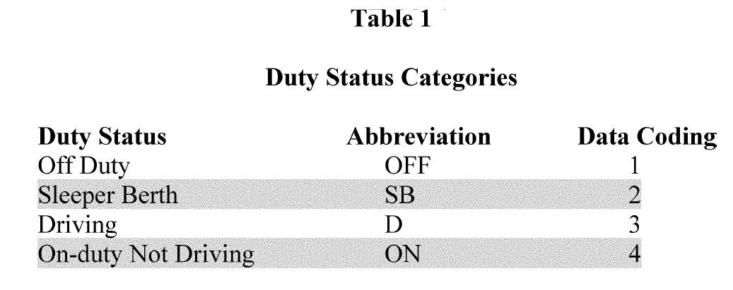

- CMV must use the information in below for special categories and driver must only be allowed to use those configured. 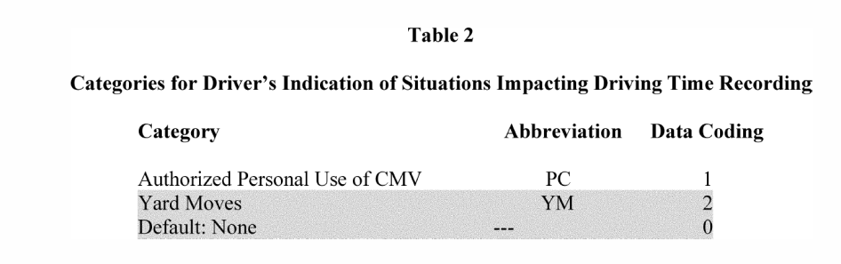
- ELD must only allow 1 category to be selected at any given time.
- ELD must prompt driver for annotation upon selection of a category from Table 2.
- ELD must default to “None” during special driving if the CMV goes through a power off cycle. (CMV’s Engines turns off and then on) except if personal use.
- ELD must prompt the driver to continue to use personal use for confirmation. If driver does not confirm and vehicle is in motion, then ELD must default to “None”
Driver’s Certification of Records
- ELD must have a function where driver can certify his/her record for 24 hour period at the end.
- ELD must prompt the driver to select “Agree” or “Not ready”.
- Driver’s affirmative select of “Agree” must be record as an event.
- ELD must only allow authenticated driver to certify only his/her records.
- If edits are required for a given 24 hour period, ELD must prompt the driver to certify his/her records again.
- If any edits are done for any previous 24 hour period rather than the current, ELD must prompt the driver to re-certify on screen display and during login and logout processes.
Driver’s Data Transfer Initiation Input
- ELD must have single-step interface for compilation of driver’s ELD records and initiation of data transfer to authorized safety officials.
- ELD must input the data transfer request from the driver, require confirmation, present and request selection of supported data transfer options by the ELD and prompt for entry of the output file comment of minimum of 60 characters long. If safety official provides a key phrase or code during an inspection to be included in out file. It must be embedded as exchanged dataset. Default value for the output file comment must be blank. ELD output file comment must be used only for the creation of a related data files for the intended time, place, and ELD user.
- Upon confirmation, ELD must generate the compliant output file and perform the data transfer.
- Single-step transfer initiation mechanism (switch or Icon on touch screen) must be clearly marked and visible to the driver when the vehicle is stopped.
Driver’s Annotation of Records.
- ELD must allow a driver to add annotation in text format to recorded, entered, or edited ELD event.
- ELD must require annotations to be 4 characters or longer including embedded spaces if driver annotation is required and driver is prompted by ELD.
Driver’s Entry of Location information
- ELD must allow driver to enter CMV’s location in text format when editing the records.
- ELD must require driver to enter the location in text format when she/he changes duty status.
- Manual location entry must show “M” in the latitude/longitude coordinates fields in ELD records.
Driver’s Record Entry/Edit
- ELD must not permit alteration or erasure of the original information collected concerning the driver’s ELD records or alteration of the source data streams used to provide that information.
- If a driver edits or annotates an ELD record or enters missing information, the act must not overwrite the original record.
- ELD must retain the original records even when allowed edits and entries are made over a driver’s ELD records.
- ELD must keep track of all event record history, and the process used by the ELD must produce the event record status, event record origin, and event type for the ELD records in the standard categories as outlined in section 7.23, 7.22, and 7.25.
- ELD must not require or allow the driver to edit or manually enter of event types: (2 intermediate log, 5 Login/Logout, 6 CMV engine power up/shutdown, 7 ELD malfunctions and data diagnostics events.
- ELD must not allow automatically recorded driving time to be shortened or the ELD username associated with an ELD record to be edited or reassigned except for Unidentified Driver, correction made for Team Driver
- If edits are made for Team driver, ELD must require each co-driver to confirm the change for the corrective action to take effect.
ELD Configuration
- ELD must only allow the carrier to configure the categories in Table 2 above for each driver. Default value will be “None”
- Motor carrier may change the categories. Changes must be communicated to the applicable driver during login process.
- ELD must allow the carrier to configure a driver to be exempt from use of an ELD.
- ELD must default to “No Exception” for all driver accounts to be created.
- ELD must prompt the motor carrier annotate the record and provide an explanation for the configuration of exemption.
- If driver is exempted then ELD must present the configured indication that is in effect for the driver during login / logout processes.
- ELD must continue to record driving time but suspend detection of missing data elements data diagnostic even for the driver
ELD Processing and Calculation
- ELD must change the duty status to driving as soon as vehicle is in motion (5 MH/h or above) unless the driver is off-duty for personal use.
- ELD must change the duty status to driving as soon as vehicle is in motion (5 MH/h or above) unless the driver is on-duty not driving during yard move.
- ELD must change the duty status to on-duty not driving when vehicle is stationary for 5 consecutive minutes and current duty status is driving. ELD allow the driver to confirm within 1 minute to continue driving otherwise change to on-duty.
- All other automatic duty status changes are prohibited.
Geo-location conversion
- ELD must convert automatically captured vehicle position in latitude/longitude coordinates into geo-location information, indicating approximate distance and direction to an identifiable location corresponding to the name of a nearby city, town, or village, with state abbreviation.
- Geo-location information must be derived from a database that contains all city, towns, and villages with a population of 5000 or greater and listed in ANSI INCITS 446-2008 (R2013).
- ELD must print the geo-location in text format.
Date and Time conversions
- ELD must have the capability to convert and track data and time captured in UTC standard to drivers home terminal time zone taking the daylight saving time changes into account by using the parameter “Time zone Offset from UTC”
- ELD must use the store driver records in standard home terminal time,.
- Time Zone Offset from UTC must be included in the Driver’s Certification of Own Records.
Event Sequence Identifier number
- ELD must feature an event sequence ID number and must use continuous numbering across all users of the ELD and across Engine and ELD power on and off cycles.
- ELD must increment sequence ID number by 1 for each event and must be able to support 65,536 unique events.
- Continuous event sequence ID numbering structure used by the ELD must be mapped into a continuous hexadecimal numbering between 0000 and FFFF (Decimal 0 and 65536).
- Automatically ELD record must set the Event Record Status to 1 (active) and Event Record Origin to 1 (automatically record by ELD).
Driver Edits to Duty Status (We must not over write any record)
- ELD must identify the record being modified for the which the "event record status" is "active" 1.
- ELD must construct the new record with the modified information, Set the new record "event record status" to "active" 1 and set the "event status record" to "inactive-changed" 2.
- ELD must set the modified record status of Event Record Origin of newly created record to 2 "edited or entered by the driver".
Driver Entries
- ELD must do the same as Driver Edits when driver enters any missing information for any record.
Driver's Assumption of Unidentified Drivers Log
- When the driver assumes any record for the unidentified driver, ELD must do the same as Driver Edits and change the Event Record Origin to "assumed from unidentified driver"
Motor Carrier Edit Suggestions
- ELD must do the same as Driver Edits when edits requested by Motor Carrier and approved by driver then only we will change the records and set the Event Record Origin to "edit requested by an authenticated user other than the driver"
Driver's Action over the Motor Carrier edit suggestions
- ELD must get confirmation from the driver for motor carrier suggested changes. If the driver confirms the changes then do same as Driver Entries. If not approved by driver then set Event Status Record to "inactive-change rejected".
Data Integrity Check Functions
- ELD must use the below table for data mapping and data check calculation.
- ELD must calculate the for all records.
Event Checksum
- Event Check sum includes <Event Type> ,<Event Type Code>, <Event Date>,<Event Time>,<Vehicle Miles>,<Engine Hours>, <Event Latitude>,<Event Longitude>,<CMV Number>, and <ELD Username>.
- ELD must sum the numeric values all individual characters making up the listed data element using character to decimal value from table 3 and use the 8-bit lower byte of the hexadecimal representation of the summed total as the event checksum value for that event.
- Checksum is calculated as: a) Three consecutive circular shift left (rotate no carry -left) operations; and (b) A bitwise exclusive OR (XOR) operation with the hexadecimal value C3 (decimal 195; binary 11000011).
Line Data Checksum
- A line data checksum must be calculated at the time of the generation of the ELD output file to transfer data to authorized official or to catalogue driver's ELD records at a motor carrier's facility.
- Checksum is calculated as: a) Three consecutive circular shift left (rotate no carry -left) operations; and (b) A bitwise exclusive OR (XOR) operation with the hexadecimal value 96 (decimal 150; binary 10010110).
- Line data checksum must be appended to end of each line.
File Data Checksum
- ELD must calculate a single 16-bit file checksum value associated with an ELD output file at the instance when an ELD output file is generated.
- ELD must sum all of the lines and use the lower two 8-bit byte value for hexadecimal representation.
- Three consecutive circular shift left (aka rotate no carry -left) operations on each 8-bit bytes of the value; and (2) A bitwise XOR operation with the hexadecimal value 969C (decimal 38556; binary 1001011010011100).
- (b) The file data check value must be the 16-bit output obtained from the above process.
- The calculated 16-bit file data check value must be converted to hexadecimal 8-bit bytes and must be appended as the last line item of the ELD output file as specified in the output file format in section 4.8.2.1.11 of this appendix.

4.5.1.1. Event: Change in Driver’s Duty Status
- ELD must include all items list in 4.5.1.1
4.5.1.2. Event: Intermediate Logs
- ELD must include all items list in 4.5.1.1 except (p) <Driver’s Location Description> when vehicle is in motion and no other duty status change has occurred in previous 1 hour.
4.5.1.3. Event: Change in Driver’s Indication of Allowed Conditions That Impact Driving Time Recording
- ELD must include all item listed in 4.5.1.1
4.5.1.4. Event: Driver’s Certification of Own Records
4.5.1.5. Event: Driver’s Login/Logout Activity
4.5.1.6. Event: CMV’s Engine Power Up and Shut Down Activity
4.5.1.7. Event: ELD Malfunction and Data Diagnostics Occurrence
4.6. ELD’s Self-Monitoring of Required Functions

